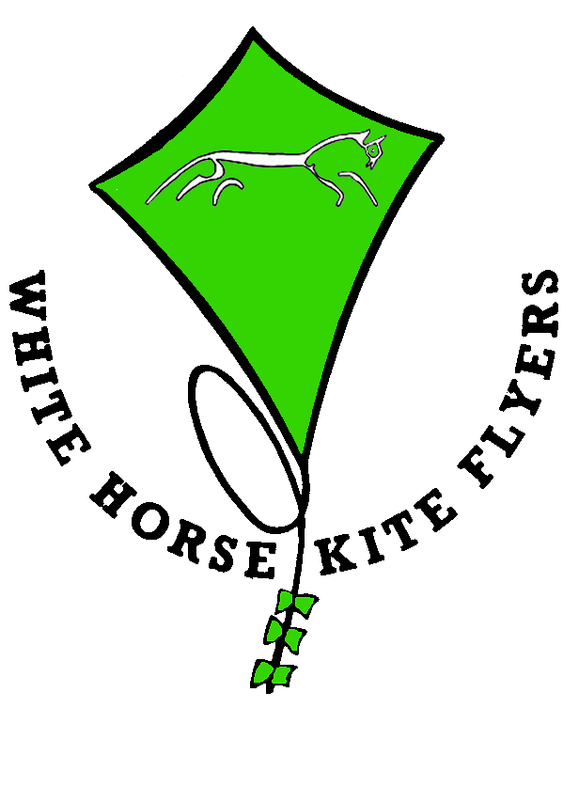
White Horse Kite Flyers
PO Box 585

Swindon

SN3 4YR
www.whkf.org.uk
info@whkf.org.uk

BOOKING FORM
The spring workshop for 2014 is a 5-sided twisted box to be taught by Jan van Leeuwen from Holland, frequently seen at events in the UK flying his School Bus. There are two options:-
1) Sparred with Carbon fibre at a cost of £75
2) Sparred with glass fibre at a cost of £65
The construction uses a special central hub that is not commercially available. There are various colour combinations on offer (see below) and these must be requested in advance.
The workshop will be held over the weekend of 15th & 16th March at the usual venue of:-
St.Joseph’s Catholic College, Ocotal Way, Swindon, SN3 3LR.
Lunch on both days is included in the price and tea and coffee are available free of charge but please bring your own mug. Please advise if you are vegetarian.
If you are attending but not making a kite, lunch is £5 per day but please let us know in advance so that we can cater for the right numbers.
A non-refundable deposit of £30 is required to secure your place.
The usual bag raffle will be held over the weekend and drawn on Sunday afternoon. Your generosity and deep pockets will be appreciated.
In recent years we have booked a restaurant for a group meal on the Saturday evening at a cost of about £20 per head. This has proved a very popular social function so we propose to do the same again. If you are interested please indicate in the box below.
Good value, convenient accommodation is available especially if you book well in advance.
For further details please go to:- www.whkf.org/JvL.html

NAME  PHONE NUMBER  EMAIL  SATURDAY EVENING MEAL YES NO VEGETARIAN  Please return this slip with your deposit to:  WHKF  P.O. Box 585  Swindon  SN3 4YR  Cheques payable to WHKF  To pay on line our Bank is RBS:  Sort code 16-33-11: Account 12573018  (If you do this please email us this completed form with details of the payment.) | COLOURS  See below  (PLEASE TICK)  WHITE/RED  WHITE/YELLOW  WHITE/PURPLE  WHITE/BLUE  WHITE/BLACK  BLACK/RED  BLACK/YELLOW  BLACK/PURPLE  BLACK/BLUE  BLACK/WHITE  CARBON  GLASS FIBRE
